25Q4 SandboxPeoplehub Missing Authentication to
Session Binding retest

Table of Contents
Introduction: 3
Target 3
25Q4 SanboxPeoplehub Missing Authentication to Session Binding retest 4

Introduction:

As part of the follow-up security assessment, a focused manual re-test was conducted to validate the remediation applied for the previously reported issue: Missing Authentication to Session Binding. The objective of this re-test was to verify whether the implemented fixes effectively address the identified weaknesses in the authentication flow, particularly around the binding of authenticated identities to active sessions.
The re-test concentrated on evaluating the integrity of authentication parameters, enforcement of session-to-identity linkage, handling of redirect and callback flows, and validation of security controls such as protection against replay or session-related attacks. Testing was performed in a controlled environment using targeted request manipulation and manual inspection to confirm whether the authentication implementation now resists the previously demonstrated attack scenarios.

Target

The audit scope

- 20.208.56.83
  - https://testpeoplehub.zalaris.com

25Q4 SandboxPeopleHub Missing Authentication to Session Binding retest

Severity | High
Requires attacker authentication | Yes
Requires victim interaction | No
CVSS v3.1 | 8.8

Description

The application does not enforce proper binding between:
- The authorization code, user session and authentication flow
As a result, if an attacker intercepts the authorization code before the legitimate client redeems it, they can redeem it themselves and obtain valid session tokens. Even though the code is single-use and short-lived, this does not prevent exploitation — the attacker only needs to redeem it once, and whoever redeems it first gains the authenticated session.

The issue is assigned High Severity due to the following reason
- Attacker needs only one stolen code
- No victim interaction required
- No cookie manipulation required
- Works cross-session, cross-user
The server fails to verify:
- Who initiated the authentication request
- Whether the returned authorization code belongs to:
- the same browser session
- the same user
- the same state / nonce
- the same client context
Instead it blindly trusts that “whoever presents this code owns the session”
Scenario
Two users authenticate in parallel.
User A opens login → gets auth_code_A
User B opens login → gets auth_code_B
This confirms:
- No validation of state
- No session binding
- No correlation between requestor ↔ auth response

Steps to reproduce

- Complete a valid login with User A and User B.
- Refer screenshot attached below
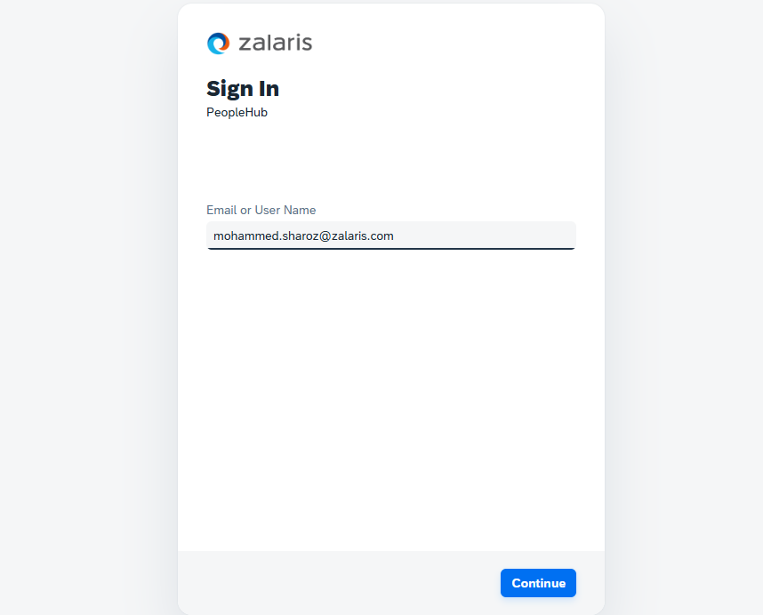

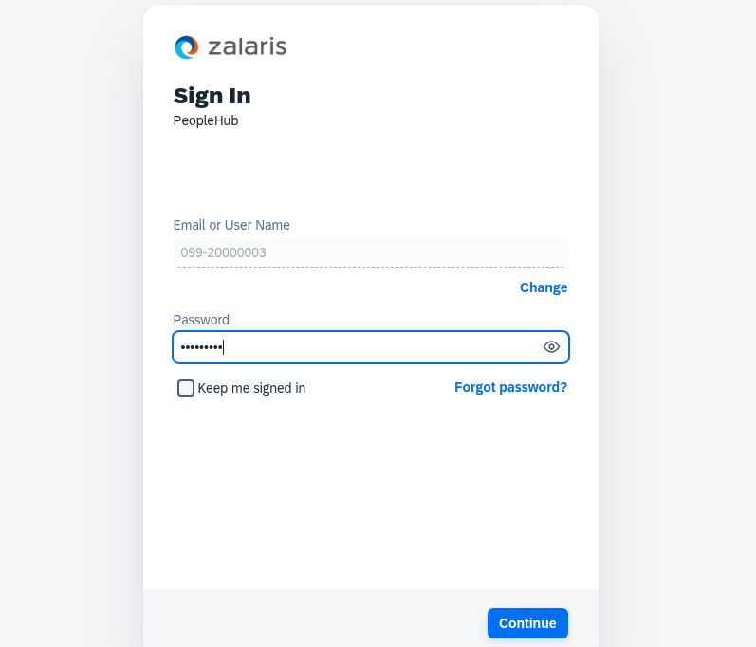
- Capture the callback request from IdP to testpeoplehub.zalaris.com for User A and User B.
- Refer screenshot attached below for the call back request for User A and User B.
User A IdP callback Request
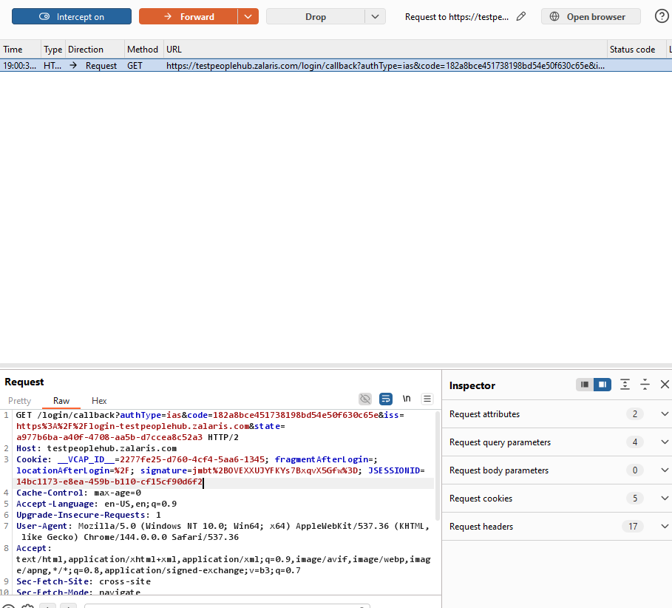

User B Idp callback Request
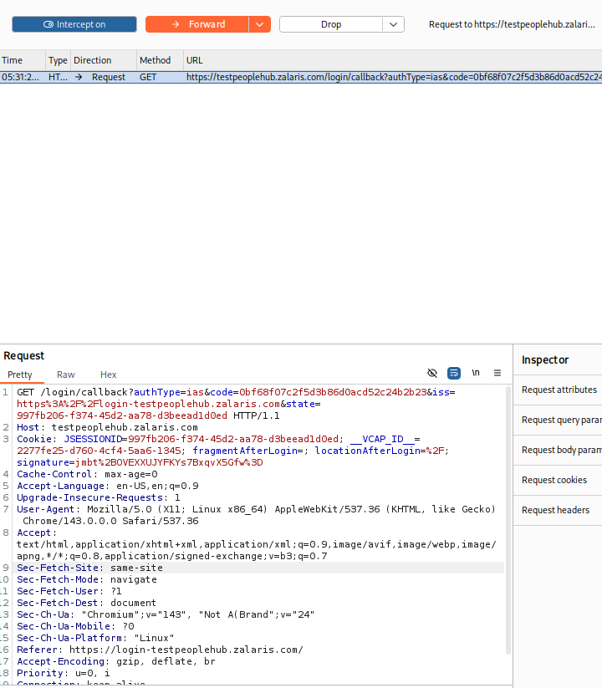

- Send callback request by changing User B’s authentication code with User A’s authentication code.

- Upon giving User B code in User A’s authentication flow, User A lands in User B’s session and User B Lands in User A’s Session.
- Tested by access User A’ session in local host and User B’s session in Virtal machine
- When the code is swapped User A session is available in the VM and User B’s Session is received in the Host machine
- Refer screenshot attached below for evidence

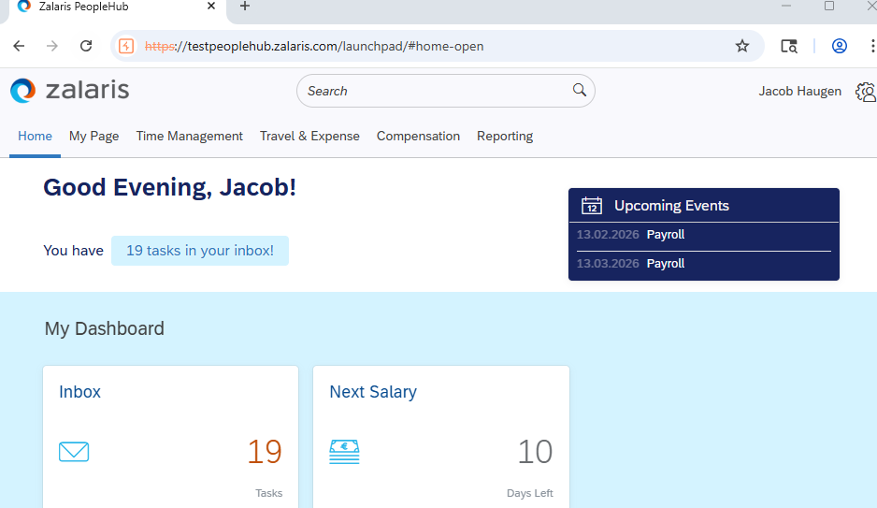

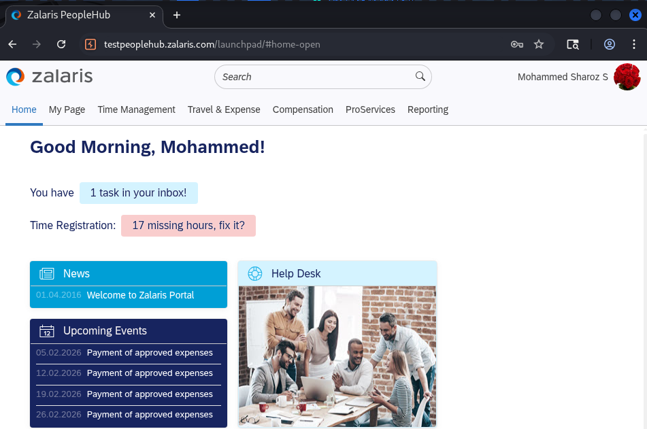

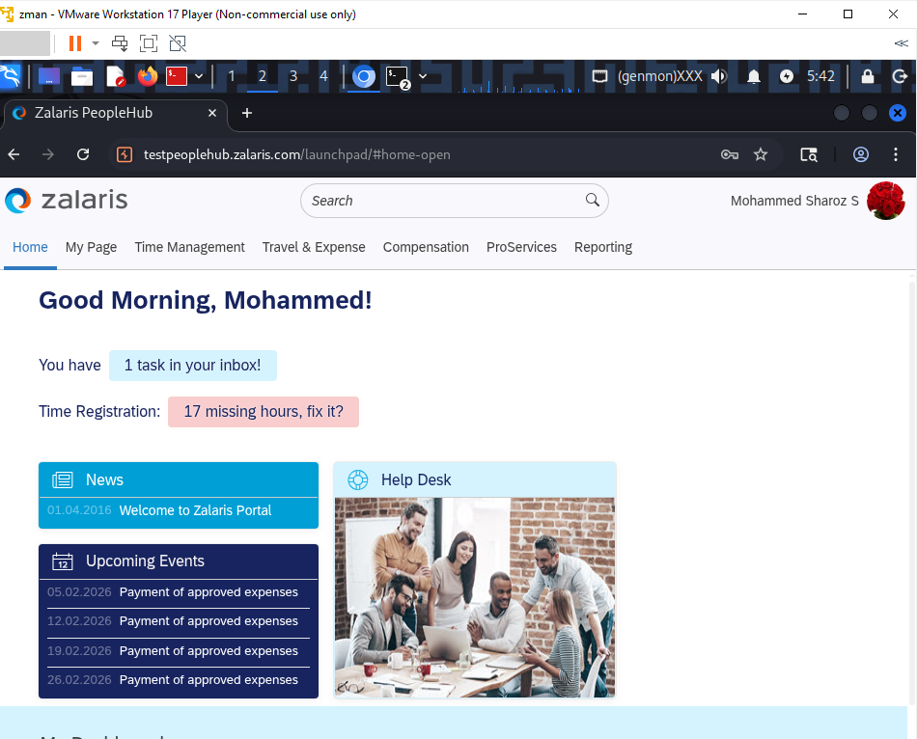

- This confirms that Authentication Code to session binding is not implemented

Expected Secure Flow

Correct behavior:

- User initiates login
- Server generates:
- State
- Stores mapping:
- session_id → expected auth_code / state / user
- On redirect Verify
- State matches
- Session exists
- Auth code unused [this check is available same auth code cannot be re-used again]
- Same browser/session
- Only then:
- Create authenticated session

Issue Found: Authentication code to session binding is not implemented.

